1 run......

Downloading: 100%

464/464 [00:00<00:00, 15.6kB/s]

Downloading: 100%

270M/270M [00:07<00:00, 44.2MB/s]

training 1 epoch...

3.2559800148010254 seconds used......

1 training finished! average train loss: 1.3065378315308516

evaluating...

Confusion matrix, without normalization

[[ 29 9 3]

[ 69 5 21]

[293 127 294]]

Normalized confusion matrix

[[0.70731707 0.2195122 0.07317073]

[0.72631579 0.05263158 0.22105263]

[0.41036415 0.17787115 0.41176471]]

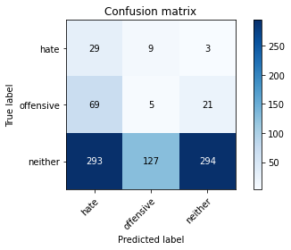

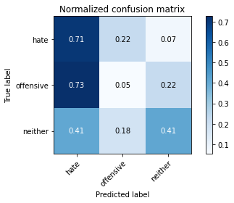

precision recall f1-score support

hate 0.07 0.71 0.13 41

offensive 0.04 0.05 0.04 95

neither 0.92 0.41 0.57 714

accuracy 0.39 850

macro avg 0.34 0.39 0.25 850

weighted avg 0.78 0.39 0.49 850

average eval_loss: 1.1192435899446176, accuracy: 0.38588235294117645

training 2 epoch...

2.3846993446350098 seconds used......

2 training finished! average train loss: 1.0646322474760168

evaluating...

Confusion matrix, without normalization

[[ 4 33 4]

[ 4 53 38]

[ 63 332 319]]

Normalized confusion matrix

[[0.09756098 0.80487805 0.09756098]

[0.04210526 0.55789474 0.4 ]

[0.08823529 0.46498599 0.44677871]]

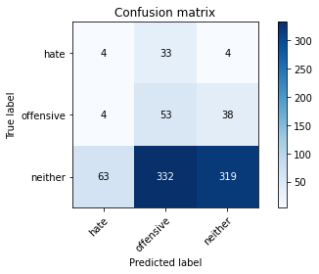

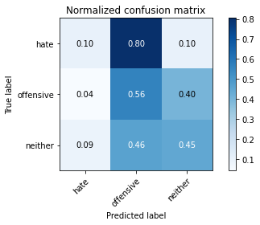

precision recall f1-score support

hate 0.06 0.10 0.07 41

offensive 0.13 0.56 0.21 95

neither 0.88 0.45 0.59 714

accuracy 0.44 850

macro avg 0.36 0.37 0.29 850

weighted avg 0.76 0.44 0.53 850

average eval_loss: 1.028364498947942, accuracy: 0.4423529411764706

training 3 epoch...

2.364539623260498 seconds used......

3 training finished! average train loss: 1.0099789500236511

evaluating...

Confusion matrix, without normalization

[[ 8 32 1]

[ 5 89 1]

[ 93 505 116]]

Normalized confusion matrix

[[0.19512195 0.7804878 0.02439024]

[0.05263158 0.93684211 0.01052632]

[0.1302521 0.70728291 0.16246499]]

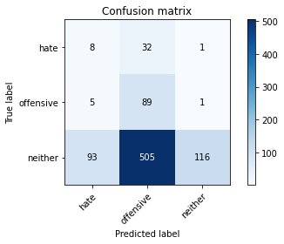

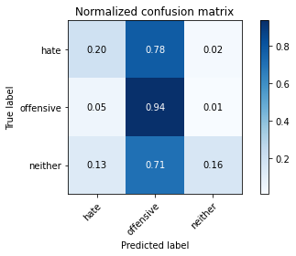

precision recall f1-score support

hate 0.08 0.20 0.11 41

offensive 0.14 0.94 0.25 95

neither 0.98 0.16 0.28 714

accuracy 0.25 850

macro avg 0.40 0.43 0.21 850

weighted avg 0.85 0.25 0.27 850

average eval_loss: 1.203586807084638, accuracy: 0.25058823529411767

training 4 epoch...

2.421285629272461 seconds used......

4 training finished! average train loss: 0.8950029296033523

evaluating...

Confusion matrix, without normalization

[[ 20 20 1]

[ 18 73 4]

[152 323 239]]

Normalized confusion matrix

[[0.48780488 0.48780488 0.02439024]

[0.18947368 0.76842105 0.04210526]

[0.21288515 0.45238095 0.33473389]]

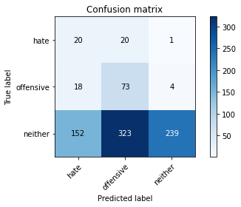

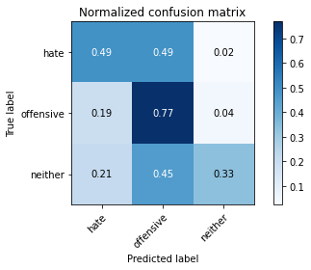

precision recall f1-score support

hate 0.11 0.49 0.17 41

offensive 0.18 0.77 0.29 95

neither 0.98 0.33 0.50 714

accuracy 0.39 850

macro avg 0.42 0.53 0.32 850

weighted avg 0.85 0.39 0.46 850

average eval_loss: 1.0959545665009076, accuracy: 0.3905882352941176

training 5 epoch...

2.346135139465332 seconds used......

5 training finished! average train loss: 0.7445736983243156

evaluating...

Confusion matrix, without normalization

[[ 25 13 3]

[ 37 49 9]

[254 205 255]]

Normalized confusion matrix

[[0.6097561 0.31707317 0.07317073]

[0.38947368 0.51578947 0.09473684]

[0.3557423 0.28711485 0.35714286]]

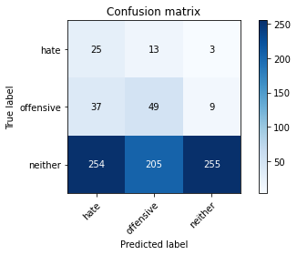

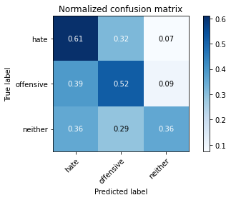

precision recall f1-score support

hate 0.08 0.61 0.14 41

offensive 0.18 0.52 0.27 95

neither 0.96 0.36 0.52 714

accuracy 0.39 850

macro avg 0.41 0.49 0.31 850

weighted avg 0.83 0.39 0.47 850

average eval_loss: 1.1625020032705262, accuracy: 0.3870588235294118

training 6 epoch...

2.3881311416625977 seconds used......

6 training finished! average train loss: 0.5622021801331464

evaluating...

Confusion matrix, without normalization

[[ 29 3 9]

[ 45 24 26]

[217 88 409]]

Normalized confusion matrix

[[0.70731707 0.07317073 0.2195122 ]

[0.47368421 0.25263158 0.27368421]

[0.30392157 0.1232493 0.57282913]]

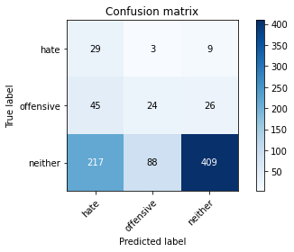

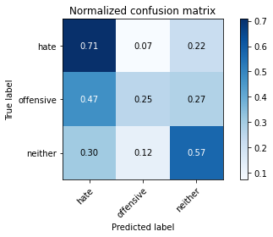

precision recall f1-score support

hate 0.10 0.71 0.17 41

offensive 0.21 0.25 0.23 95

neither 0.92 0.57 0.71 714

accuracy 0.54 850

macro avg 0.41 0.51 0.37 850

weighted avg 0.80 0.54 0.63 850

average eval_loss: 0.9920490955890611, accuracy: 0.5435294117647059

training 7 epoch...

2.3508763313293457 seconds used......

7 training finished! average train loss: 0.35361209950026345

evaluating...

Confusion matrix, without normalization

[[ 23 7 11]

[ 26 32 37]

[178 100 436]]

Normalized confusion matrix

[[0.56097561 0.17073171 0.26829268]

[0.27368421 0.33684211 0.38947368]

[0.24929972 0.14005602 0.61064426]]

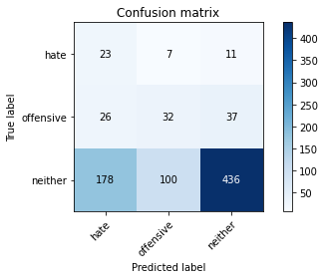

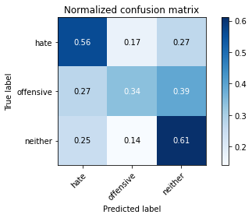

precision recall f1-score support

hate 0.10 0.56 0.17 41

offensive 0.23 0.34 0.27 95

neither 0.90 0.61 0.73 714

accuracy 0.58 850

macro avg 0.41 0.50 0.39 850

weighted avg 0.79 0.58 0.65 850

average eval_loss: 0.9783758765389753, accuracy: 0.5776470588235294

training 8 epoch...

2.387136459350586 seconds used......

8 training finished! average train loss: 0.19071325002347722

evaluating...

Confusion matrix, without normalization

[[ 11 17 13]

[ 9 62 24]

[ 95 248 371]]

Normalized confusion matrix

[[0.26829268 0.41463415 0.31707317]

[0.09473684 0.65263158 0.25263158]

[0.13305322 0.34733894 0.51960784]]

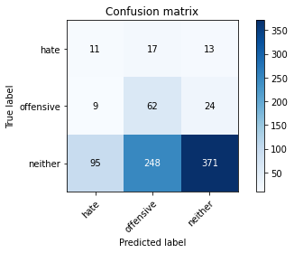

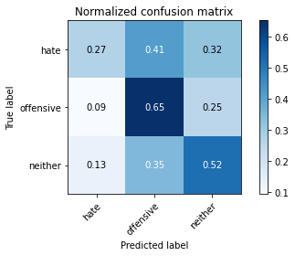

precision recall f1-score support

hate 0.10 0.27 0.14 41

offensive 0.19 0.65 0.29 95

neither 0.91 0.52 0.66 714

accuracy 0.52 850

macro avg 0.40 0.48 0.37 850

weighted avg 0.79 0.52 0.60 850

average eval_loss: 1.1438539953425872, accuracy: 0.5223529411764706

training 9 epoch...

2.3639304637908936 seconds used......

9 training finished! average train loss: 0.07335325768765281

evaluating...

Confusion matrix, without normalization

[[ 18 10 13]

[ 28 32 35]

[166 116 432]]

Normalized confusion matrix

[[0.43902439 0.24390244 0.31707317]

[0.29473684 0.33684211 0.36842105]

[0.232493 0.16246499 0.60504202]]

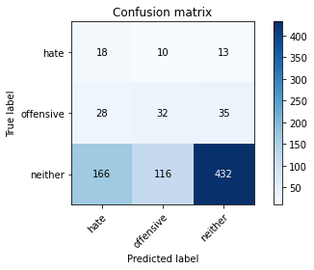

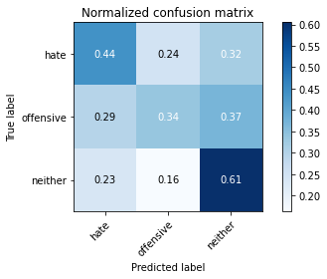

precision recall f1-score support

hate 0.08 0.44 0.14 41

offensive 0.20 0.34 0.25 95

neither 0.90 0.61 0.72 714

accuracy 0.57 850

macro avg 0.40 0.46 0.37 850

weighted avg 0.78 0.57 0.64 850

average eval_loss: 1.201949490017669, accuracy: 0.5670588235294117

training 10 epoch...

2.4100124835968018 seconds used......

10 training finished! average train loss: 0.03457774024675874

evaluating...

Confusion matrix, without normalization

[[ 19 11 11]

[ 25 53 17]

[184 182 348]]

Normalized confusion matrix

[[0.46341463 0.26829268 0.26829268]

[0.26315789 0.55789474 0.17894737]

[0.25770308 0.25490196 0.48739496]]

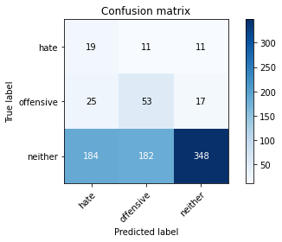

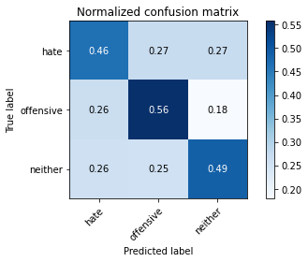

precision recall f1-score support

hate 0.08 0.46 0.14 41

offensive 0.22 0.56 0.31 95

neither 0.93 0.49 0.64 714

accuracy 0.49 850

macro avg 0.41 0.50 0.36 850

weighted avg 0.81 0.49 0.58 850

average eval_loss: 1.5544553759486177, accuracy: 0.49411764705882355

2 run......

training 1 epoch...

2.3750665187835693 seconds used......

1 training finished! average train loss: 1.2640132623560287

evaluating...

Confusion matrix, without normalization

[[ 25 3 13]

[ 9 17 69]

[174 124 416]]

Normalized confusion matrix

[[0.6097561 0.07317073 0.31707317]

[0.09473684 0.17894737 0.72631579]

[0.24369748 0.17366947 0.58263305]]

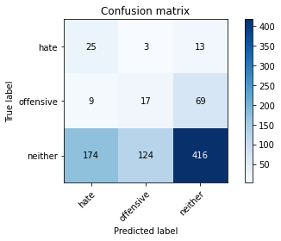

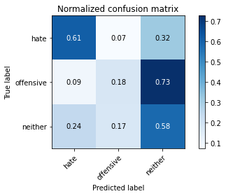

precision recall f1-score support

hate 0.12 0.61 0.20 41

offensive 0.12 0.18 0.14 95

neither 0.84 0.58 0.69 714

accuracy 0.54 850

macro avg 0.36 0.46 0.34 850

weighted avg 0.72 0.54 0.60 850

average eval_loss: 1.0832889759263327, accuracy: 0.5388235294117647

training 2 epoch...

2.3610219955444336 seconds used......

2 training finished! average train loss: 1.0783113100949455

evaluating...

Confusion matrix, without normalization

[[ 31 4 6]

[ 20 41 34]

[211 157 346]]

Normalized confusion matrix

[[0.75609756 0.09756098 0.14634146]

[0.21052632 0.43157895 0.35789474]

[0.29551821 0.21988796 0.48459384]]

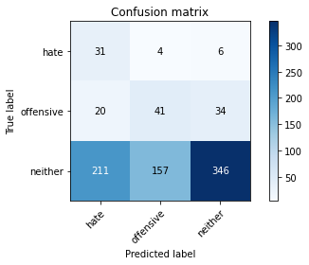

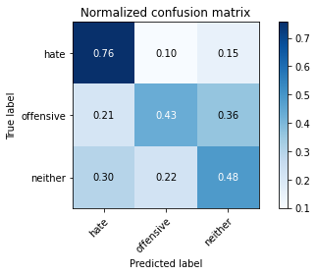

precision recall f1-score support

hate 0.12 0.76 0.20 41

offensive 0.20 0.43 0.28 95

neither 0.90 0.48 0.63 714

accuracy 0.49 850

macro avg 0.41 0.56 0.37 850

weighted avg 0.78 0.49 0.57 850

average eval_loss: 1.0426335043685382, accuracy: 0.49176470588235294

training 3 epoch...

2.396491050720215 seconds used......

3 training finished! average train loss: 1.005955664550557

evaluating...

Confusion matrix, without normalization

[[ 32 6 3]

[ 42 42 11]

[306 168 240]]

Normalized confusion matrix

[[0.7804878 0.14634146 0.07317073]

[0.44210526 0.44210526 0.11578947]

[0.42857143 0.23529412 0.33613445]]

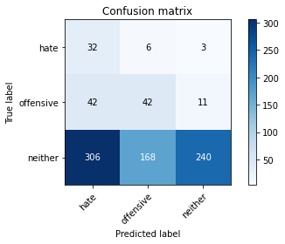

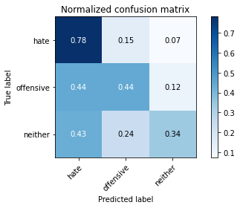

precision recall f1-score support

hate 0.08 0.78 0.15 41

offensive 0.19 0.44 0.27 95

neither 0.94 0.34 0.50 714

accuracy 0.37 850

macro avg 0.41 0.52 0.31 850

weighted avg 0.82 0.37 0.45 850

average eval_loss: 1.0817189549290858, accuracy: 0.36941176470588233

training 4 epoch...

2.353797435760498 seconds used......

4 training finished! average train loss: 0.915143864996293

evaluating...

Confusion matrix, without normalization

[[ 17 11 13]

[ 10 47 38]

[127 146 441]]

Normalized confusion matrix

[[0.41463415 0.26829268 0.31707317]

[0.10526316 0.49473684 0.4 ]

[0.17787115 0.20448179 0.61764706]]

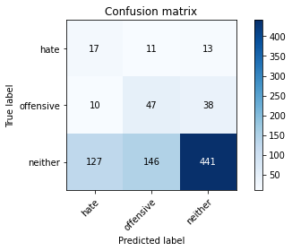

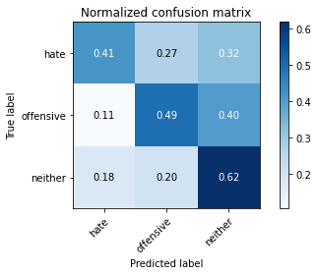

precision recall f1-score support

hate 0.11 0.41 0.17 41

offensive 0.23 0.49 0.31 95

neither 0.90 0.62 0.73 714

accuracy 0.59 850

macro avg 0.41 0.51 0.41 850

weighted avg 0.78 0.59 0.66 850

average eval_loss: 0.9033960505973461, accuracy: 0.5941176470588235

training 5 epoch...

2.396542549133301 seconds used......

5 training finished! average train loss: 0.7685620328959297

evaluating...

Confusion matrix, without normalization

[[ 30 10 1]

[ 28 65 2]

[289 243 182]]

Normalized confusion matrix

[[0.73170732 0.24390244 0.02439024]

[0.29473684 0.68421053 0.02105263]

[0.4047619 0.34033613 0.25490196]]

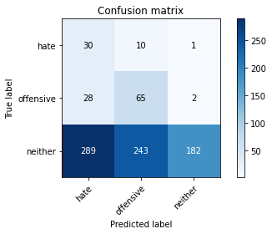

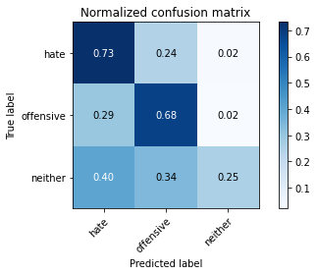

precision recall f1-score support

hate 0.09 0.73 0.15 41

offensive 0.20 0.68 0.31 95

neither 0.98 0.25 0.40 714

accuracy 0.33 850

macro avg 0.42 0.56 0.29 850

weighted avg 0.85 0.33 0.38 850

average eval_loss: 1.2740743617678798, accuracy: 0.32588235294117646

training 6 epoch...

2.3507509231567383 seconds used......

6 training finished! average train loss: 0.6333039753577289

evaluating...

Confusion matrix, without normalization

[[ 20 19 2]

[ 12 79 4]

[175 329 210]]

Normalized confusion matrix

[[0.48780488 0.46341463 0.04878049]

[0.12631579 0.83157895 0.04210526]

[0.24509804 0.46078431 0.29411765]]

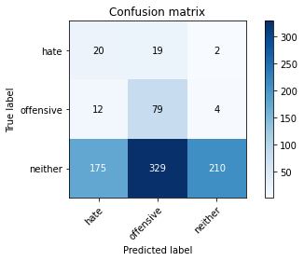

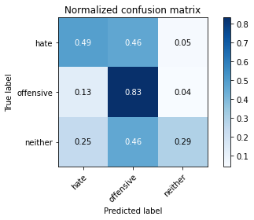

precision recall f1-score support

hate 0.10 0.49 0.16 41

offensive 0.19 0.83 0.30 95

neither 0.97 0.29 0.45 714

accuracy 0.36 850

macro avg 0.42 0.54 0.31 850

weighted avg 0.84 0.36 0.42 850

average eval_loss: 1.279778474985167, accuracy: 0.3635294117647059

training 7 epoch...

2.369917631149292 seconds used......

7 training finished! average train loss: 0.4440658846322228

evaluating...

Confusion matrix, without normalization

[[ 18 14 9]

[ 10 71 14]

[140 233 341]]

Normalized confusion matrix

[[0.43902439 0.34146341 0.2195122 ]

[0.10526316 0.74736842 0.14736842]

[0.19607843 0.32633053 0.47759104]]

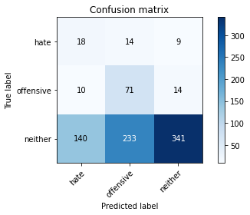

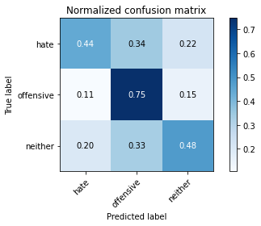

precision recall f1-score support

hate 0.11 0.44 0.17 41

offensive 0.22 0.75 0.34 95

neither 0.94 0.48 0.63 714

accuracy 0.51 850

macro avg 0.42 0.55 0.38 850

weighted avg 0.82 0.51 0.58 850

average eval_loss: 1.0794006107851517, accuracy: 0.5058823529411764

training 8 epoch...

2.3420026302337646 seconds used......

8 training finished! average train loss: 0.2785712874987546

evaluating...

Confusion matrix, without normalization

[[ 17 14 10]

[ 9 71 15]

[108 228 378]]

Normalized confusion matrix

[[0.41463415 0.34146341 0.24390244]

[0.09473684 0.74736842 0.15789474]

[0.1512605 0.31932773 0.52941176]]

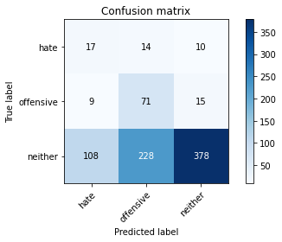

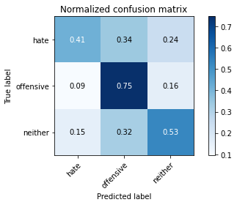

precision recall f1-score support

hate 0.13 0.41 0.19 41

offensive 0.23 0.75 0.35 95

neither 0.94 0.53 0.68 714

accuracy 0.55 850

macro avg 0.43 0.56 0.41 850

weighted avg 0.82 0.55 0.62 850

average eval_loss: 1.1064572854097499, accuracy: 0.548235294117647

training 9 epoch...

2.337697982788086 seconds used......

9 training finished! average train loss: 0.14825478196144104

evaluating...

Confusion matrix, without normalization

[[ 22 12 7]

[ 28 60 7]

[197 255 262]]

Normalized confusion matrix

[[0.53658537 0.29268293 0.17073171]

[0.29473684 0.63157895 0.07368421]

[0.27591036 0.35714286 0.36694678]]

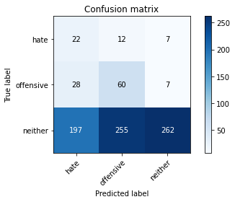

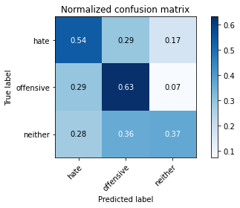

precision recall f1-score support

hate 0.09 0.54 0.15 41

offensive 0.18 0.63 0.28 95

neither 0.95 0.37 0.53 714

accuracy 0.40 850

macro avg 0.41 0.51 0.32 850

weighted avg 0.82 0.40 0.48 850

average eval_loss: 1.6767284579055255, accuracy: 0.4047058823529412

training 10 epoch...

2.360309600830078 seconds used......

10 training finished! average train loss: 0.07628558356972302

evaluating...

Confusion matrix, without normalization

[[ 21 8 12]

[ 18 45 32]

[154 140 420]]

Normalized confusion matrix

[[0.51219512 0.19512195 0.29268293]

[0.18947368 0.47368421 0.33684211]

[0.21568627 0.19607843 0.58823529]]

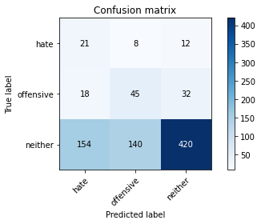

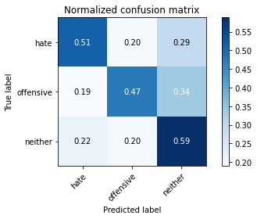

precision recall f1-score support

hate 0.11 0.51 0.18 41

offensive 0.23 0.47 0.31 95

neither 0.91 0.59 0.71 714

accuracy 0.57 850

macro avg 0.42 0.52 0.40 850

weighted avg 0.79 0.57 0.64 850

average eval_loss: 1.2871079846870068, accuracy: 0.571764705882353

3 run......

training 1 epoch...

2.3756585121154785 seconds used......

1 training finished! average train loss: 1.1851264659096212

evaluating...

Confusion matrix, without normalization

[[ 9 32 0]

[ 3 90 2]

[ 52 574 88]]

Normalized confusion matrix

[[0.2195122 0.7804878 0. ]

[0.03157895 0.94736842 0.02105263]

[0.07282913 0.80392157 0.1232493 ]]

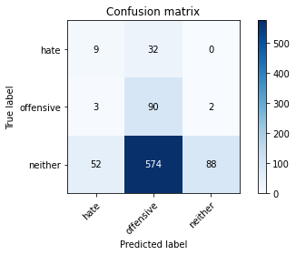

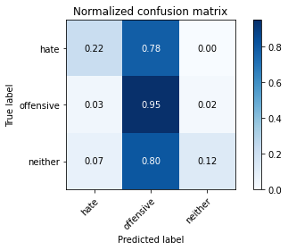

precision recall f1-score support

hate 0.14 0.22 0.17 41

offensive 0.13 0.95 0.23 95

neither 0.98 0.12 0.22 714

accuracy 0.22 850

macro avg 0.42 0.43 0.21 850

weighted avg 0.84 0.22 0.22 850

average eval_loss: 1.2399267318636873, accuracy: 0.22

training 2 epoch...

2.340304136276245 seconds used......

2 training finished! average train loss: 1.055873576332541

evaluating...

Confusion matrix, without normalization

[[ 33 2 6]

[ 24 3 68]

[219 32 463]]

Normalized confusion matrix

[[0.80487805 0.04878049 0.14634146]

[0.25263158 0.03157895 0.71578947]

[0.30672269 0.04481793 0.64845938]]

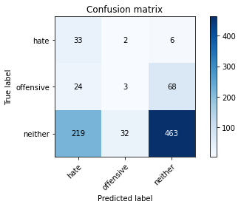

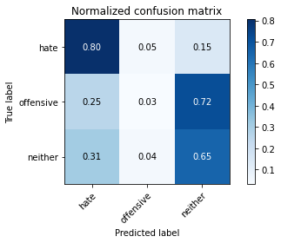

precision recall f1-score support

hate 0.12 0.80 0.21 41

offensive 0.08 0.03 0.05 95

neither 0.86 0.65 0.74 714

accuracy 0.59 850

macro avg 0.35 0.49 0.33 850

weighted avg 0.74 0.59 0.64 850

average eval_loss: 0.9803454716538273, accuracy: 0.5870588235294117

training 3 epoch...

2.3394033908843994 seconds used......

3 training finished! average train loss: 0.9796059867914986

evaluating...

Confusion matrix, without normalization

[[ 34 6 1]

[ 60 33 2]

[446 143 125]]

Normalized confusion matrix

[[0.82926829 0.14634146 0.02439024]

[0.63157895 0.34736842 0.02105263]

[0.62464986 0.20028011 0.17507003]]

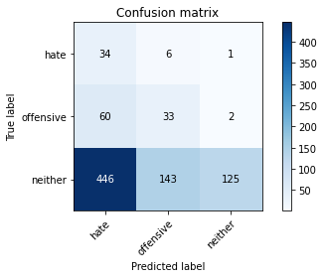

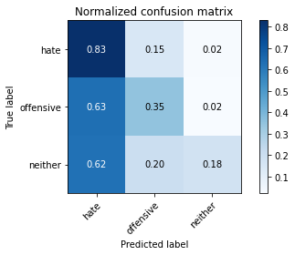

precision recall f1-score support

hate 0.06 0.83 0.12 41

offensive 0.18 0.35 0.24 95

neither 0.98 0.18 0.30 714

accuracy 0.23 850

macro avg 0.41 0.45 0.22 850

weighted avg 0.84 0.23 0.28 850

average eval_loss: 1.2887165782063505, accuracy: 0.22588235294117648

training 4 epoch...

2.3420937061309814 seconds used......

4 training finished! average train loss: 0.8787857749882866

evaluating...

Confusion matrix, without normalization

[[ 31 5 5]

[ 39 41 15]

[263 116 335]]

Normalized confusion matrix

[[0.75609756 0.12195122 0.12195122]

[0.41052632 0.43157895 0.15789474]

[0.36834734 0.16246499 0.46918768]]

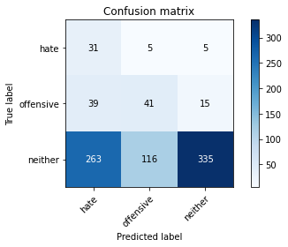

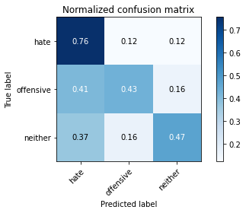

precision recall f1-score support

hate 0.09 0.76 0.17 41

offensive 0.25 0.43 0.32 95

neither 0.94 0.47 0.63 714

accuracy 0.48 850

macro avg 0.43 0.55 0.37 850

weighted avg 0.83 0.48 0.57 850

average eval_loss: 1.0125679103441017, accuracy: 0.4788235294117647

training 5 epoch...

2.349281072616577 seconds used......

5 training finished! average train loss: 0.7128600898910972

evaluating...

Confusion matrix, without normalization

[[ 33 4 4]

[ 38 21 36]

[287 47 380]]

Normalized confusion matrix

[[0.80487805 0.09756098 0.09756098]

[0.4 0.22105263 0.37894737]

[0.40196078 0.06582633 0.53221289]]

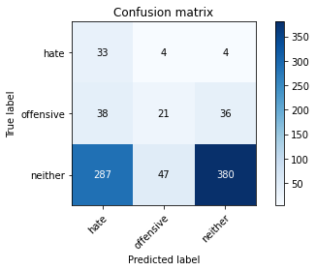

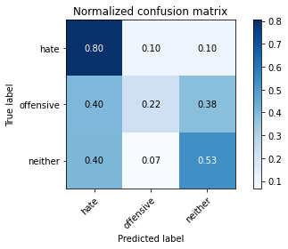

precision recall f1-score support

hate 0.09 0.80 0.17 41

offensive 0.29 0.22 0.25 95

neither 0.90 0.53 0.67 714

accuracy 0.51 850

macro avg 0.43 0.52 0.36 850

weighted avg 0.80 0.51 0.60 850

average eval_loss: 0.9973482648993648, accuracy: 0.5105882352941177

training 6 epoch...

2.3375518321990967 seconds used......

6 training finished! average train loss: 0.4945847567389993

evaluating...

Confusion matrix, without normalization

[[ 21 9 11]

[ 10 62 23]

[135 134 445]]

Normalized confusion matrix

[[0.51219512 0.2195122 0.26829268]

[0.10526316 0.65263158 0.24210526]

[0.18907563 0.18767507 0.6232493 ]]

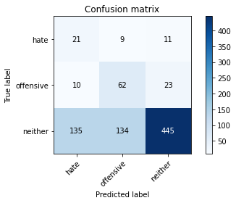

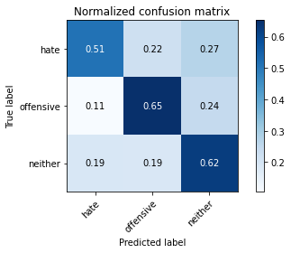

precision recall f1-score support

hate 0.13 0.51 0.20 41

offensive 0.30 0.65 0.41 95

neither 0.93 0.62 0.75 714

accuracy 0.62 850

macro avg 0.45 0.60 0.45 850

weighted avg 0.82 0.62 0.68 850

average eval_loss: 0.8427482683991276, accuracy: 0.6211764705882353

training 7 epoch...

2.3678011894226074 seconds used......

7 training finished! average train loss: 0.31620971683193655

evaluating...

Confusion matrix, without normalization

[[ 22 12 7]

[ 7 79 9]

[135 268 311]]

Normalized confusion matrix

[[0.53658537 0.29268293 0.17073171]

[0.07368421 0.83157895 0.09473684]

[0.18907563 0.37535014 0.43557423]]

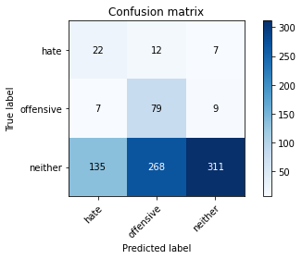

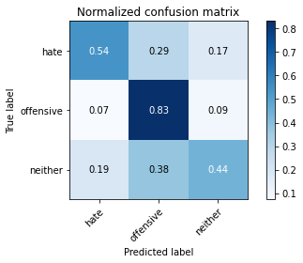

precision recall f1-score support

hate 0.13 0.54 0.21 41

offensive 0.22 0.83 0.35 95

neither 0.95 0.44 0.60 714

accuracy 0.48 850

macro avg 0.44 0.60 0.39 850

weighted avg 0.83 0.48 0.55 850

average eval_loss: 1.1901450115580892, accuracy: 0.48470588235294115

training 8 epoch...

2.339261054992676 seconds used......

8 training finished! average train loss: 0.14576801920638366

evaluating...

Confusion matrix, without normalization

[[ 22 13 6]

[ 12 69 14]

[151 211 352]]

Normalized confusion matrix

[[0.53658537 0.31707317 0.14634146]

[0.12631579 0.72631579 0.14736842]

[0.21148459 0.29551821 0.4929972 ]]

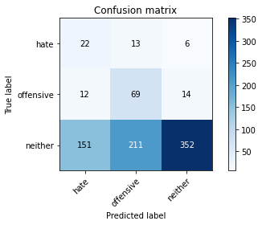

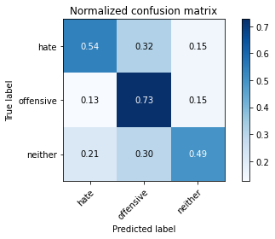

precision recall f1-score support

hate 0.12 0.54 0.19 41

offensive 0.24 0.73 0.36 95

neither 0.95 0.49 0.65 714

accuracy 0.52 850

macro avg 0.43 0.59 0.40 850

weighted avg 0.83 0.52 0.59 850

average eval_loss: 1.2021458058856254, accuracy: 0.5211764705882352

training 9 epoch...

2.363413095474243 seconds used......

9 training finished! average train loss: 0.062120921581107026

evaluating...

Confusion matrix, without normalization

[[ 18 15 8]

[ 7 74 14]

[129 218 367]]

Normalized confusion matrix

[[0.43902439 0.36585366 0.19512195]

[0.07368421 0.77894737 0.14736842]

[0.18067227 0.30532213 0.5140056 ]]

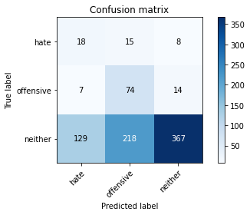

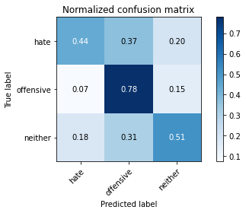

precision recall f1-score support

hate 0.12 0.44 0.18 41

offensive 0.24 0.78 0.37 95

neither 0.94 0.51 0.67 714

accuracy 0.54 850

macro avg 0.43 0.58 0.41 850

weighted avg 0.83 0.54 0.61 850

average eval_loss: 1.2439834981463676, accuracy: 0.54

training 10 epoch...

2.409226417541504 seconds used......

10 training finished! average train loss: 0.034228401696857286

evaluating...

Confusion matrix, without normalization

[[ 26 12 3]

[ 13 70 12]

[160 208 346]]

Normalized confusion matrix

[[0.63414634 0.29268293 0.07317073]

[0.13684211 0.73684211 0.12631579]

[0.22408964 0.29131653 0.48459384]]

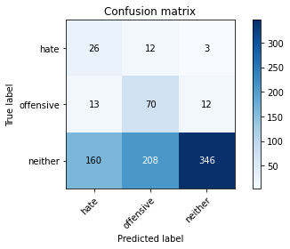

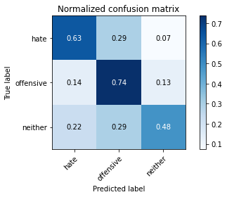

precision recall f1-score support

hate 0.13 0.63 0.22 41

offensive 0.24 0.74 0.36 95

neither 0.96 0.48 0.64 714

accuracy 0.52 850

macro avg 0.44 0.62 0.41 850

weighted avg 0.84 0.52 0.59 850

average eval_loss: 1.421314661932546, accuracy: 0.52

4 run......

training 1 epoch...

2.377223253250122 seconds used......

1 training finished! average train loss: 1.1587567048914291

evaluating...

Confusion matrix, without normalization

[[ 15 25 1]

[ 13 80 2]

[205 364 145]]

Normalized confusion matrix

[[0.36585366 0.6097561 0.02439024]

[0.13684211 0.84210526 0.02105263]

[0.28711485 0.50980392 0.20308123]]

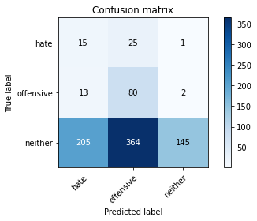

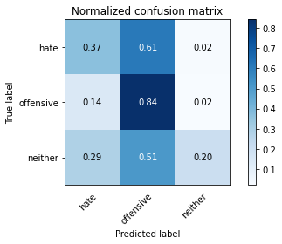

precision recall f1-score support

hate 0.06 0.37 0.11 41

offensive 0.17 0.84 0.28 95

neither 0.98 0.20 0.34 714

accuracy 0.28 850

macro avg 0.40 0.47 0.24 850

weighted avg 0.85 0.28 0.32 850

average eval_loss: 1.1552846653516902, accuracy: 0.2823529411764706

training 2 epoch...

2.387568235397339 seconds used......

2 training finished! average train loss: 1.0389710699810701

evaluating...

Confusion matrix, without normalization

[[ 38 2 1]

[ 68 23 4]

[430 79 205]]

Normalized confusion matrix

[[0.92682927 0.04878049 0.02439024]

[0.71578947 0.24210526 0.04210526]

[0.6022409 0.11064426 0.28711485]]

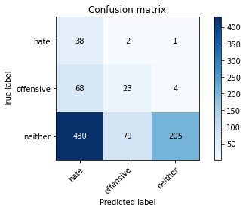

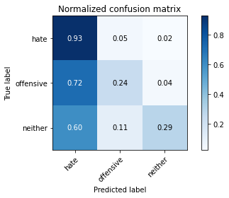

precision recall f1-score support

hate 0.07 0.93 0.13 41

offensive 0.22 0.24 0.23 95

neither 0.98 0.29 0.44 714

accuracy 0.31 850

macro avg 0.42 0.49 0.27 850

weighted avg 0.85 0.31 0.40 850

average eval_loss: 1.1310659757880277, accuracy: 0.3129411764705882

training 3 epoch...

2.3526101112365723 seconds used......

3 training finished! average train loss: 0.9411320090293884

evaluating...

Confusion matrix, without normalization

[[ 38 0 3]

[ 56 2 37]

[343 25 346]]

Normalized confusion matrix

[[0.92682927 0. 0.07317073]

[0.58947368 0.02105263 0.38947368]

[0.48039216 0.03501401 0.48459384]]

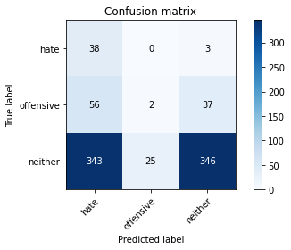

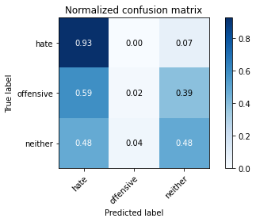

precision recall f1-score support

hate 0.09 0.93 0.16 41

offensive 0.07 0.02 0.03 95

neither 0.90 0.48 0.63 714

accuracy 0.45 850

macro avg 0.35 0.48 0.27 850

weighted avg 0.77 0.45 0.54 850

average eval_loss: 0.9895619396553483, accuracy: 0.4541176470588235

training 4 epoch...

2.394505500793457 seconds used......

4 training finished! average train loss: 0.826835926841287

evaluating...

Confusion matrix, without normalization

[[ 32 7 2]

[ 42 42 11]

[314 132 268]]

Normalized confusion matrix

[[0.7804878 0.17073171 0.04878049]

[0.44210526 0.44210526 0.11578947]

[0.43977591 0.18487395 0.37535014]]

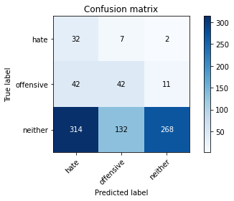

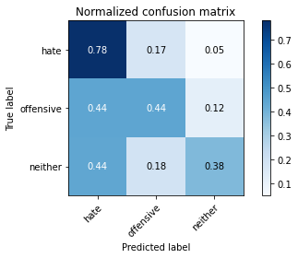

precision recall f1-score support

hate 0.08 0.78 0.15 41

offensive 0.23 0.44 0.30 95

neither 0.95 0.38 0.54 714

accuracy 0.40 850

macro avg 0.42 0.53 0.33 850

weighted avg 0.83 0.40 0.49 850

average eval_loss: 1.116493444110072, accuracy: 0.4023529411764706

training 5 epoch...

2.4046154022216797 seconds used......

5 training finished! average train loss: 0.6241403257145601

evaluating...

Confusion matrix, without normalization

[[ 32 5 4]

[ 49 22 24]

[278 96 340]]

Normalized confusion matrix

[[0.7804878 0.12195122 0.09756098]

[0.51578947 0.23157895 0.25263158]

[0.38935574 0.13445378 0.47619048]]

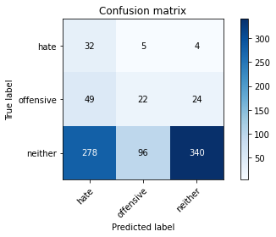

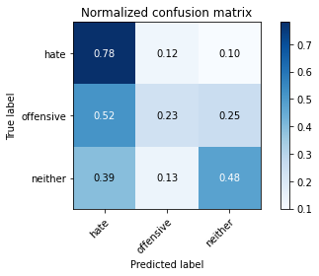

precision recall f1-score support

hate 0.09 0.78 0.16 41

offensive 0.18 0.23 0.20 95

neither 0.92 0.48 0.63 714

accuracy 0.46 850

macro avg 0.40 0.50 0.33 850

weighted avg 0.80 0.46 0.56 850

average eval_loss: 1.0736990577952807, accuracy: 0.46352941176470586

training 6 epoch...

2.3684520721435547 seconds used......

6 training finished! average train loss: 0.45073939070982094

evaluating...

Confusion matrix, without normalization

[[ 22 4 15]

[ 17 10 68]

[146 87 481]]

Normalized confusion matrix

[[0.53658537 0.09756098 0.36585366]

[0.17894737 0.10526316 0.71578947]

[0.20448179 0.12184874 0.67366947]]

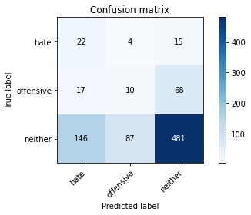

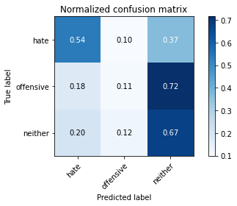

precision recall f1-score support

hate 0.12 0.54 0.19 41

offensive 0.10 0.11 0.10 95

neither 0.85 0.67 0.75 714

accuracy 0.60 850

macro avg 0.36 0.44 0.35 850

weighted avg 0.73 0.60 0.65 850

average eval_loss: 0.8933489267216173, accuracy: 0.6035294117647059

training 7 epoch...

2.350473642349243 seconds used......

7 training finished! average train loss: 0.2540810178307926

evaluating...

Confusion matrix, without normalization

[[ 21 12 8]

[ 12 50 33]

[142 173 399]]

Normalized confusion matrix

[[0.51219512 0.29268293 0.19512195]

[0.12631579 0.52631579 0.34736842]

[0.19887955 0.24229692 0.55882353]]

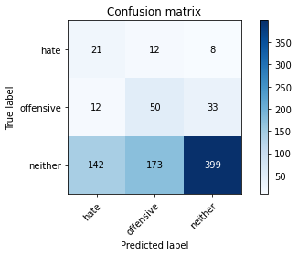

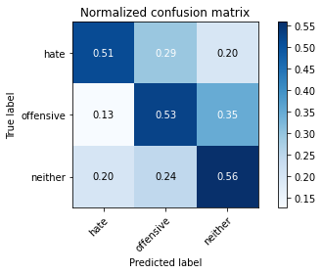

precision recall f1-score support

hate 0.12 0.51 0.19 41

offensive 0.21 0.53 0.30 95

neither 0.91 0.56 0.69 714

accuracy 0.55 850

macro avg 0.41 0.53 0.40 850

weighted avg 0.79 0.55 0.62 850

average eval_loss: 1.063839504885119, accuracy: 0.5529411764705883

training 8 epoch...

2.3513684272766113 seconds used......

8 training finished! average train loss: 0.13596710650359883

evaluating...

Confusion matrix, without normalization

[[ 19 8 14]

[ 12 45 38]

[122 140 452]]

Normalized confusion matrix

[[0.46341463 0.19512195 0.34146341]

[0.12631579 0.47368421 0.4 ]

[0.17086835 0.19607843 0.63305322]]

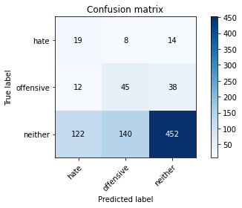

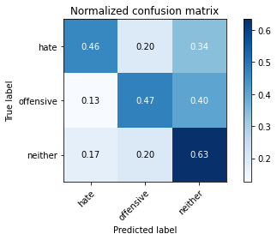

precision recall f1-score support

hate 0.12 0.46 0.20 41

offensive 0.23 0.47 0.31 95

neither 0.90 0.63 0.74 714

accuracy 0.61 850

macro avg 0.42 0.52 0.42 850

weighted avg 0.79 0.61 0.67 850

average eval_loss: 0.9983428328536278, accuracy: 0.6070588235294118

training 9 epoch...

2.3512401580810547 seconds used......

9 training finished! average train loss: 0.08604075595298234

evaluating...

Confusion matrix, without normalization

[[ 10 24 7]

[ 2 78 15]

[ 56 278 380]]

Normalized confusion matrix

[[0.24390244 0.58536585 0.17073171]

[0.02105263 0.82105263 0.15789474]

[0.07843137 0.38935574 0.53221289]]

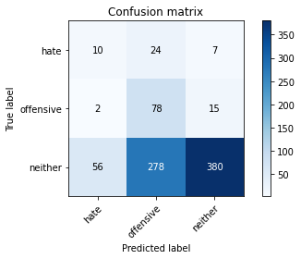

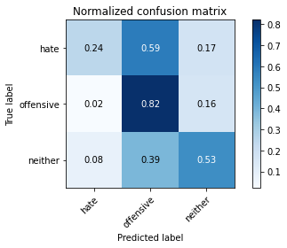

precision recall f1-score support

hate 0.15 0.24 0.18 41

offensive 0.21 0.82 0.33 95

neither 0.95 0.53 0.68 714

accuracy 0.55 850

macro avg 0.43 0.53 0.40 850

weighted avg 0.82 0.55 0.62 850

average eval_loss: 1.3142411390016244, accuracy: 0.5505882352941176

training 10 epoch...

2.4086220264434814 seconds used......

10 training finished! average train loss: 0.04475156173986547

evaluating...

Confusion matrix, without normalization

[[ 16 18 7]

[ 6 61 28]

[103 216 395]]

Normalized confusion matrix

[[0.3902439 0.43902439 0.17073171]

[0.06315789 0.64210526 0.29473684]

[0.1442577 0.30252101 0.55322129]]

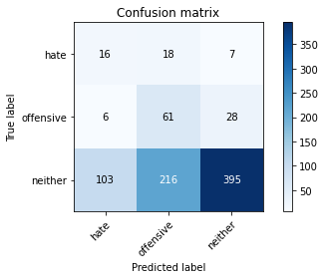

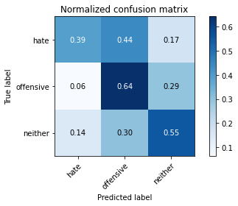

precision recall f1-score support

hate 0.13 0.39 0.19 41

offensive 0.21 0.64 0.31 95

neither 0.92 0.55 0.69 714

accuracy 0.56 850

macro avg 0.42 0.53 0.40 850

weighted avg 0.80 0.56 0.62 850

average eval_loss: 1.3366195732770965, accuracy: 0.5552941176470588

5 run......

training 1 epoch...

2.3747339248657227 seconds used......

1 training finished! average train loss: 1.2279224395751953

evaluating...

Confusion matrix, without normalization

[[ 0 41 0]

[ 1 91 3]

[ 40 641 33]]

Normalized confusion matrix

[[0. 1. 0. ]

[0.01052632 0.95789474 0.03157895]

[0.05602241 0.8977591 0.04621849]]

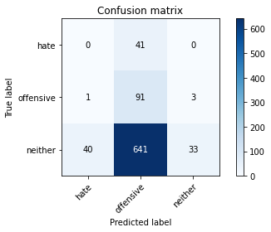

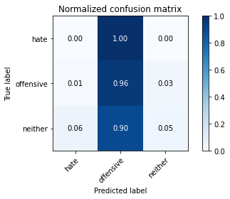

precision recall f1-score support

hate 0.00 0.00 0.00 41

offensive 0.12 0.96 0.21 95

neither 0.92 0.05 0.09 714

accuracy 0.15 850

macro avg 0.34 0.33 0.10 850

weighted avg 0.78 0.15 0.10 850

average eval_loss: 1.1707879415778226, accuracy: 0.14588235294117646

training 2 epoch...

2.3515822887420654 seconds used......

2 training finished! average train loss: 1.0741731173851912

evaluating...

Confusion matrix, without normalization

[[ 22 18 1]

[ 30 61 4]

[306 259 149]]

Normalized confusion matrix

[[0.53658537 0.43902439 0.02439024]

[0.31578947 0.64210526 0.04210526]

[0.42857143 0.3627451 0.20868347]]

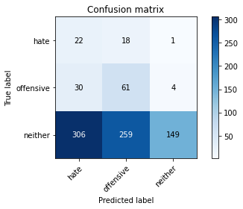

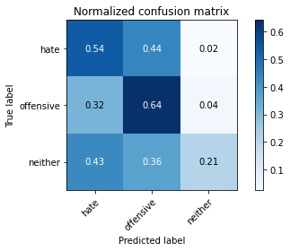

precision recall f1-score support

hate 0.06 0.54 0.11 41

offensive 0.18 0.64 0.28 95

neither 0.97 0.21 0.34 714

accuracy 0.27 850

macro avg 0.40 0.46 0.25 850

weighted avg 0.84 0.27 0.33 850

average eval_loss: 1.147386866946553, accuracy: 0.27294117647058824

training 3 epoch...

2.3537826538085938 seconds used......

3 training finished! average train loss: 0.9931056499481201

evaluating...

Confusion matrix, without normalization

[[ 17 20 4]

[ 7 33 55]

[117 137 460]]

Normalized confusion matrix

[[0.41463415 0.48780488 0.09756098]

[0.07368421 0.34736842 0.57894737]

[0.16386555 0.19187675 0.6442577 ]]

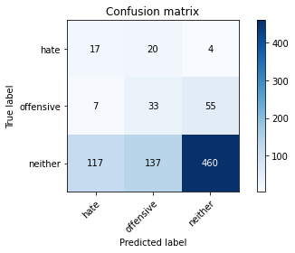

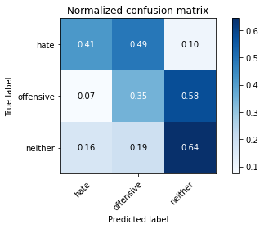

precision recall f1-score support

hate 0.12 0.41 0.19 41

offensive 0.17 0.35 0.23 95

neither 0.89 0.64 0.75 714

accuracy 0.60 850

macro avg 0.39 0.47 0.39 850

weighted avg 0.77 0.60 0.66 850

average eval_loss: 0.9293860599052074, accuracy: 0.6

training 4 epoch...

2.3536794185638428 seconds used......

4 training finished! average train loss: 0.8969978129162508

evaluating...

Confusion matrix, without normalization

[[ 25 6 10]

[ 18 6 71]

[166 57 491]]

Normalized confusion matrix

[[0.6097561 0.14634146 0.24390244]

[0.18947368 0.06315789 0.74736842]

[0.232493 0.07983193 0.68767507]]

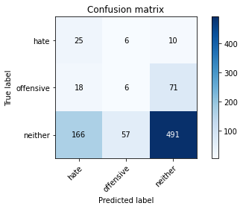

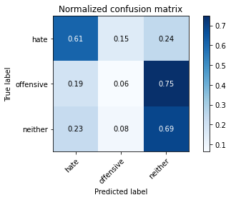

precision recall f1-score support

hate 0.12 0.61 0.20 41

offensive 0.09 0.06 0.07 95

neither 0.86 0.69 0.76 714

accuracy 0.61 850

macro avg 0.35 0.45 0.35 850

weighted avg 0.74 0.61 0.66 850

average eval_loss: 0.8756784630376239, accuracy: 0.6141176470588235

training 5 epoch...

2.414241313934326 seconds used......

5 training finished! average train loss: 0.7422145534964169

evaluating...

Confusion matrix, without normalization

[[ 33 5 3]

[ 57 29 9]

[402 60 252]]

Normalized confusion matrix

[[0.80487805 0.12195122 0.07317073]

[0.6 0.30526316 0.09473684]

[0.56302521 0.08403361 0.35294118]]

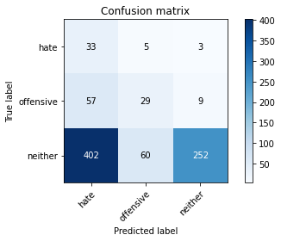

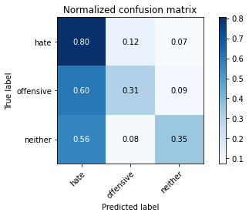

precision recall f1-score support

hate 0.07 0.80 0.12 41

offensive 0.31 0.31 0.31 95

neither 0.95 0.35 0.52 714

accuracy 0.37 850

macro avg 0.44 0.49 0.32 850

weighted avg 0.84 0.37 0.47 850

average eval_loss: 1.1906523690667263, accuracy: 0.36941176470588233

training 6 epoch...

2.4072296619415283 seconds used......

6 training finished! average train loss: 0.5364120935692507

evaluating...

Confusion matrix, without normalization

[[ 19 14 8]

[ 7 65 23]

[116 178 420]]

Normalized confusion matrix

[[0.46341463 0.34146341 0.19512195]

[0.07368421 0.68421053 0.24210526]

[0.16246499 0.24929972 0.58823529]]

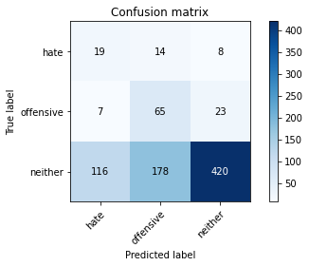

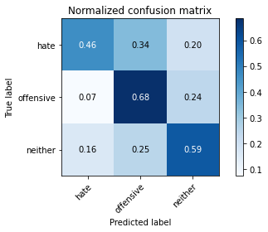

precision recall f1-score support

hate 0.13 0.46 0.21 41

offensive 0.25 0.68 0.37 95

neither 0.93 0.59 0.72 714

accuracy 0.59 850

macro avg 0.44 0.58 0.43 850

weighted avg 0.82 0.59 0.66 850

average eval_loss: 0.8869631255781928, accuracy: 0.5929411764705882

training 7 epoch...

2.354980707168579 seconds used......

7 training finished! average train loss: 0.3598373418345171

evaluating...

Confusion matrix, without normalization

[[ 26 13 2]

[ 21 69 5]

[273 197 244]]

Normalized confusion matrix

[[0.63414634 0.31707317 0.04878049]

[0.22105263 0.72631579 0.05263158]

[0.38235294 0.27591036 0.34173669]]

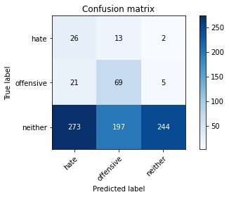

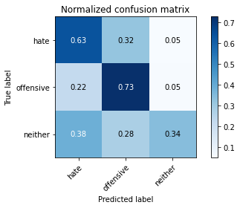

precision recall f1-score support

hate 0.08 0.63 0.14 41

offensive 0.25 0.73 0.37 95

neither 0.97 0.34 0.51 714

accuracy 0.40 850

macro avg 0.43 0.57 0.34 850

weighted avg 0.85 0.40 0.47 850

average eval_loss: 1.421208931263103, accuracy: 0.3988235294117647

training 8 epoch...

2.400303840637207 seconds used......

8 training finished! average train loss: 0.18867869499851675

evaluating...

Confusion matrix, without normalization

[[ 18 5 18]

[ 10 30 55]

[137 86 491]]

Normalized confusion matrix

[[0.43902439 0.12195122 0.43902439]

[0.10526316 0.31578947 0.57894737]

[0.19187675 0.12044818 0.68767507]]

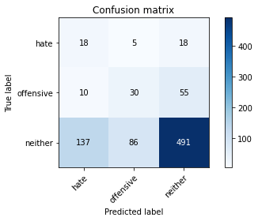

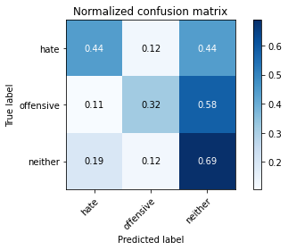

precision recall f1-score support

hate 0.11 0.44 0.17 41

offensive 0.25 0.32 0.28 95

neither 0.87 0.69 0.77 714

accuracy 0.63 850

macro avg 0.41 0.48 0.41 850

weighted avg 0.76 0.63 0.68 850

average eval_loss: 0.883419637763223, accuracy: 0.6341176470588236

training 9 epoch...

2.3530592918395996 seconds used......

9 training finished! average train loss: 0.09826886631986674

evaluating...

Confusion matrix, without normalization

[[ 21 6 14]

[ 10 40 45]

[153 118 443]]

Normalized confusion matrix

[[0.51219512 0.14634146 0.34146341]

[0.10526316 0.42105263 0.47368421]

[0.21428571 0.16526611 0.62044818]]

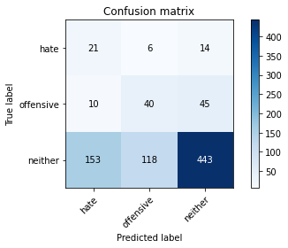

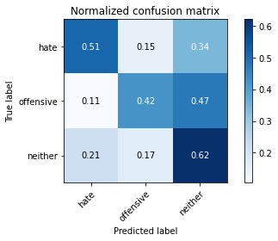

precision recall f1-score support

hate 0.11 0.51 0.19 41

offensive 0.24 0.42 0.31 95

neither 0.88 0.62 0.73 714

accuracy 0.59 850

macro avg 0.41 0.52 0.41 850

weighted avg 0.77 0.59 0.66 850

average eval_loss: 1.0277117799187816, accuracy: 0.5929411764705882

training 10 epoch...

2.3696210384368896 seconds used......

10 training finished! average train loss: 0.037872914498781454

evaluating...

Confusion matrix, without normalization

[[ 22 5 14]

[ 16 35 44]

[194 93 427]]

Normalized confusion matrix

[[0.53658537 0.12195122 0.34146341]

[0.16842105 0.36842105 0.46315789]

[0.27170868 0.1302521 0.59803922]]

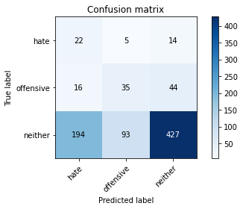

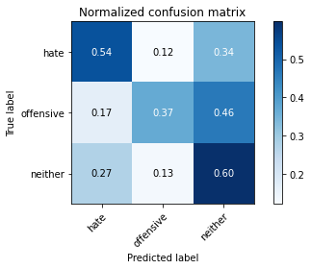

precision recall f1-score support

hate 0.09 0.54 0.16 41

offensive 0.26 0.37 0.31 95

neither 0.88 0.60 0.71 714

accuracy 0.57 850

macro avg 0.41 0.50 0.39 850

weighted avg 0.77 0.57 0.64 850

average eval_loss: 1.229879917446957, accuracy: 0.5694117647058824